Technical Report

Title: PicMus Stream

National College of Ireland

HCC

2014

Name: Kevin Surname: Fitzpatrick

Student ID: x12477932

Email: kfitzpatrick75@gmail.com

Name: Leon Surname: Daly

Student ID: x12112381

Email: kingidas@gmail.com

Name: Paul Surname: Cuffe

Student ID: x11378541

Email: paulcuffe117@gmail.com

Name: Ronan Surname: Smith

Student ID: x11357556

Email: ronan.smith@outlook.com

Name: Darragh Surname: O Conchuir

Student ID: x1538083

Email: [darraghoc1992@gmail.com](mailto:darraghoc1992@gmail.com)

**1 Introduction**

1.1 Overview

Our mash up allows users to enter a query in a search bar which will then display audio, videos and images relevant to the query taken from our APIS( YouTube and Flickr). The user may also register an account with our mash up allowing them to sign into their own account which will allow extra functionality (work in progress).

1.2 Motivation

We are motivated to work on this project because our group is interested in improving our knowledge of coding and learning the most effective way to work as a team for future projects. We would also like to create something that is meaningful to a wide group of people and easy to use. For this reason we have chosen to base our mash up around music as it appeals to a wide array of people, and allows us to make our mash up simple allowing people to use it rather easily.

1.3 How it was done?

Our mash up is coded using mainly PHP however certain elements are done in JavaScript. As PHP is used in the mash up a local host is required for the mash up to function, in our case we used Apache for our local host. Leon worked on both the database and the sound cloud API and coded it using PHP. Kevin and Paul worked on getting the YouTube API functioning, it calls the YouTube API with the use of JavaScript. The Flickr API was done by Darragh and Ronan and also functions through the use of JavaScript.

**2 Requirements specification**

2.1 Use Case model

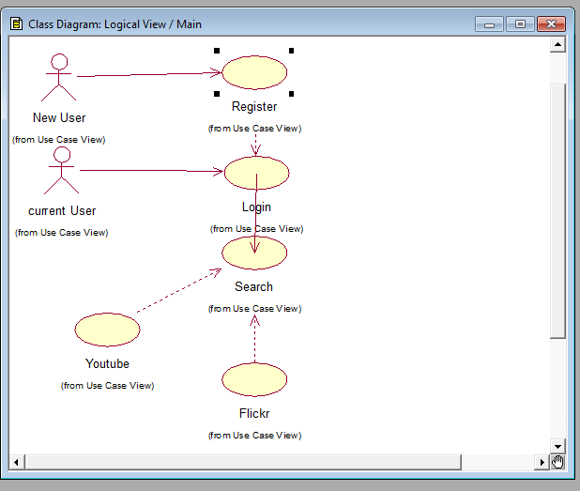

2.2 GUI

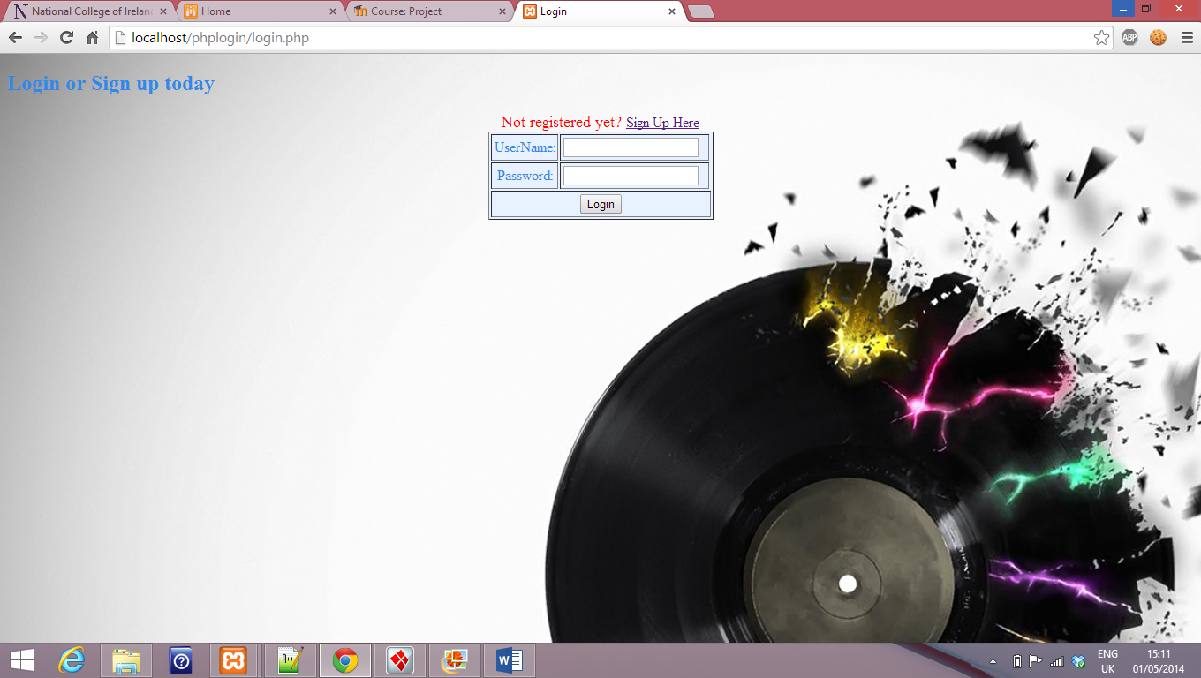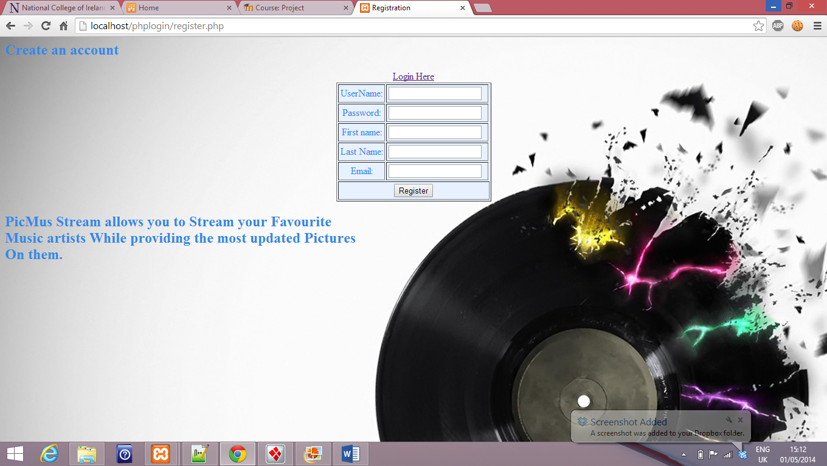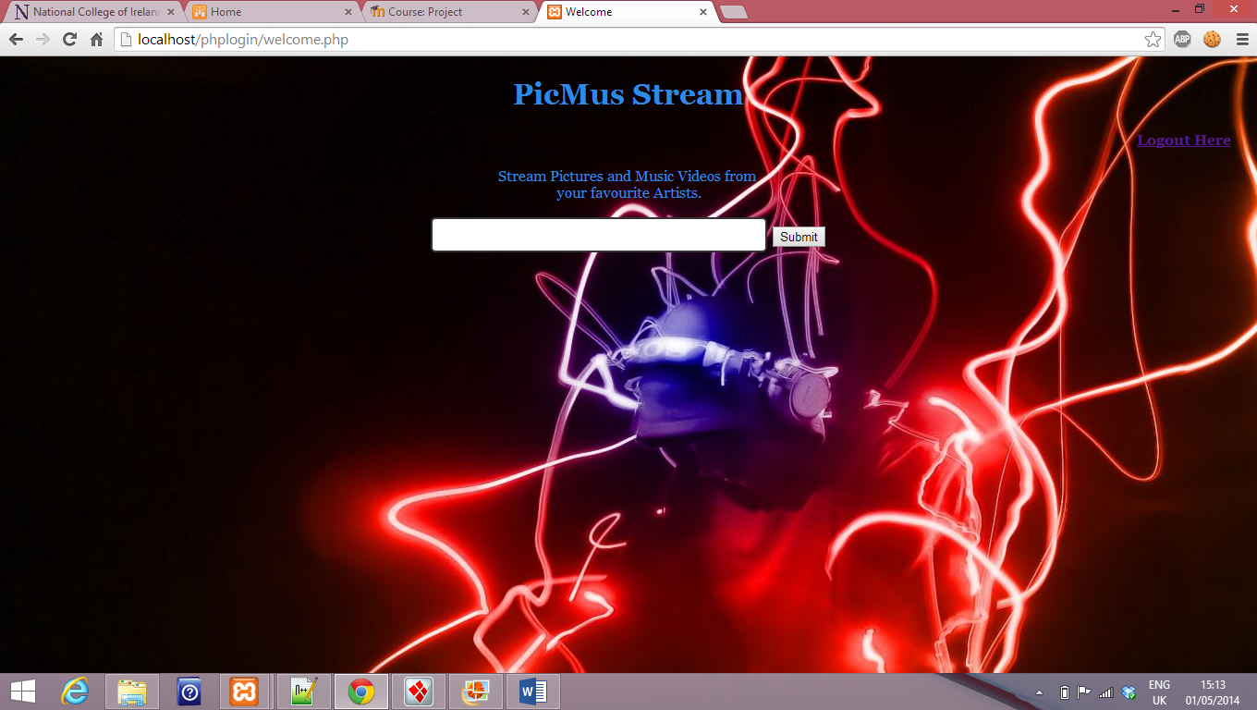

2.3 Dataflow Diagram

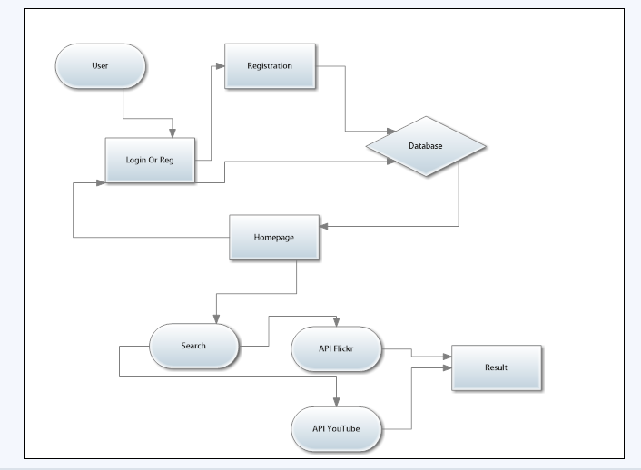

3 **Feedback session discussions**

Discussions and reflections regarding:

1. Learning /Skills

2. Process – the Project development process

3. Client Feedback Session

1. **Learning/skills**

From working on the mash up our group has learned some valuable lessons. We learned how to better work in a team and the importance of proper communication, what a mash up is and how to make one, how to code in PHP/JavaScript/SQL and how to code a functioning database.

1. **Process**

At the beginning of the project the team was dedicated to doing research about mash ups and thinking of potential ideas that our team could use for our own mash up. We decided to go with a mash up based on a music Quiz idea called “I’ll be bach”. The group couldn’t make much headway working on our original idea so we decided instead to do a mash up based on displaying pictures/music/audio with a different name (PicMus stream) and interface. We initially ran into to trouble working with the API’s but eventually made progress.

3. **Client feedback session**

3. In our presentation for the feedback session it was pointed out that the group made several mistakes such as not introducing the members of the group, and not explaining our idea clearly. We felt this was justified criticism and will make efforts to fix these mistakes for the actual presentation. We intend to introduce ourselves at the beginning of the presentation and clearly elaborate on our mash up so there is no confusion as to what we are doing.

**4 Future works**

In the future we will add more functionality through our mash ups and personalize the mash up more through our login system and social media apps. This will help make our mash up more distinct and interesting to use compared to similar applications.

**5** **References**

1. XAMPP Installers and Downloads for Apache Friends. 2014. *XAMPP Installers and Downloads for Apache Friends*. [ONLINE] Available at:<https://www.apachefriends.org/index.html>. [Accessed 01 May 2014].
2. PHP: mysql_db_query - Manual . 2014. PHP: mysql_db_query - Manual. [ONLINE] Available at: <http://www.php.net/manual/en/function.mysql-db-query.php>. [Accessed 01 May 2014].
3. how to use phpmyadmin in xampp - YouTube. 2014. how to use phpmyadmin in xampp - YouTube. [ONLINE] Available at: <http://www.youtube.com/results?search_query=how+to+use+phpmyadmin+in+xampp>. [Accessed 01 May 2014].
4. login system with php - YouTube. 2014. login system with php - YouTube. [ONLINE] Available at: <http://www.youtube.com/results?search_query=login+system+with+php>. [Accessed 01 May 2014].
5. how to use localhost - YouTube. 2014. how to use localhost - YouTube. [ONLINE] Available at: <http://www.youtube.com/results?search_query=how+to+use+localhost>. [Accessed 01 May 2014].
6. what are apis mashups - YouTube. 2014. what are apis mashups - YouTube. [ONLINE] Available at: <http://www.youtube.com/results?search_query=what+are+apis+mashups>. [Accessed 01 May 2014]
7. ProgrammableWeb - Mashups, APIs, and the Web as Platform. 2014.ProgrammableWeb - Mashups, APIs, and the Web as Platform. [ONLINE] Available at: <http://www.programmableweb.com/>. [Accessed 01 May 2014].
8. 10 Top US Cities Travel Guides - ProgrammableWeb Mashup Detail. 2014.10 Top US Cities Travel Guides - ProgrammableWeb Mashup Detail. [ONLINE] Available at: <http://www.programmableweb.com/mashup/10-top-us-cities-travel-guides>. [Accessed 01 May 2014].
9. Google Developers. 2014. Google Developers. [ONLINE] Available at:<https://developers.google.com/>. [Accessed 01 May 2014].
10. youtube-api-samples - YouTube API Sample Applications - Google Project Hosting . 2014. youtube-api-samples - YouTube API Sample Applications - Google Project Hosting. [ONLINE] Available at:<https://code.google.com/p/youtube-api-samples/>. [Accessed 01 May 2014].
11. Flickr Services. 2014. Flickr Services. [ONLINE] Available at:<https://www.flickr.com/services/api/>. [Accessed 01 May 2014].
12. Mashape API | Codecademy. 2014. Mashape API | Codecademy. [ONLINE] Available at: <http://www.codecademy.com/tracks/mashape>. [Accessed 01 May 2014].
13. How To Install XAMPP 1.8.1 On Windows 8 - YouTube. 2014. How To Install XAMPP 1.8.1 On Windows 8 - YouTube. [ONLINE] Available

at:<http://www.youtube.com/watch?v=Fxo4_DX4ejU>. [Accessed 01 May 2014].

1. Apache Friends Support Forum • View topic - cannot access localhost. 2014.Apache Friends Support Forum • View topic - cannot access localhost. [ONLINE] Available at: <https://community.apachefriends.org/f/viewtopic.php?f=16&t=47975>. [Accessed 01 May 2014].
2. PHP inside JavaScript? - Hot Scripts Forums. 2014. PHP inside JavaScript? - Hot Scripts Forums. [ONLINE] Available at:<http://www.hotscripts.com/forums/javascript/39278-php-inside-javascript.html>. [Accessed 01 May 2014].